[1] CSA-1557 CLOUD COMPUTING LAB PRACTICAL

10.Create a simple cloud software application for online supermarkets using any Cloud Service Provider to demonstrate SaaS with the template of customer name, address, phone, email, items, quantity etc. with the item classification form.

STEP-1:

Login into zoho.com and create an account.Then go to zoho creator and create a new application starting with a new form.Add or insert the required fields.

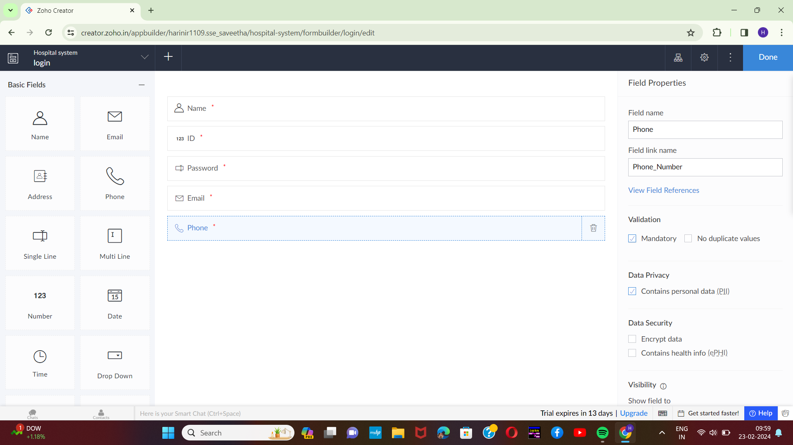

STEP-2:

Execute or run the model and get the required login form in live.

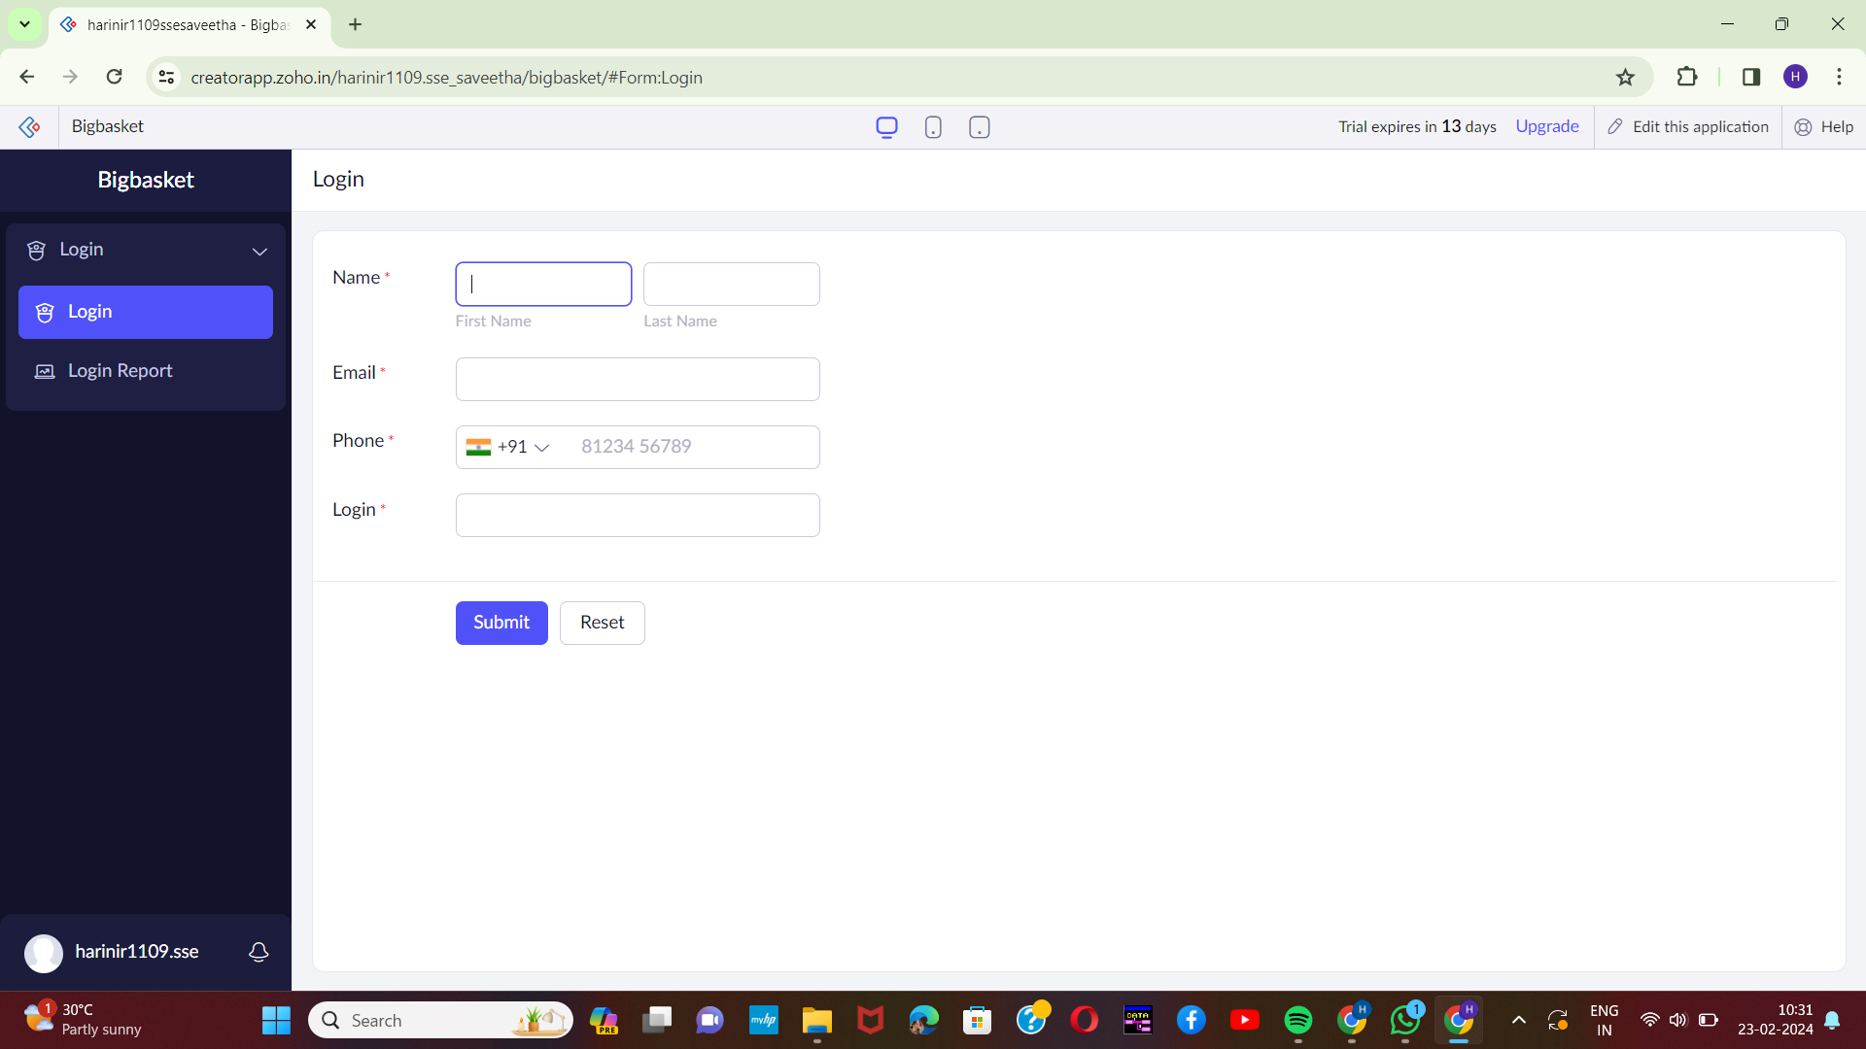[2]

STEP-3:

Next step is to add another form which consists of items with the fields.

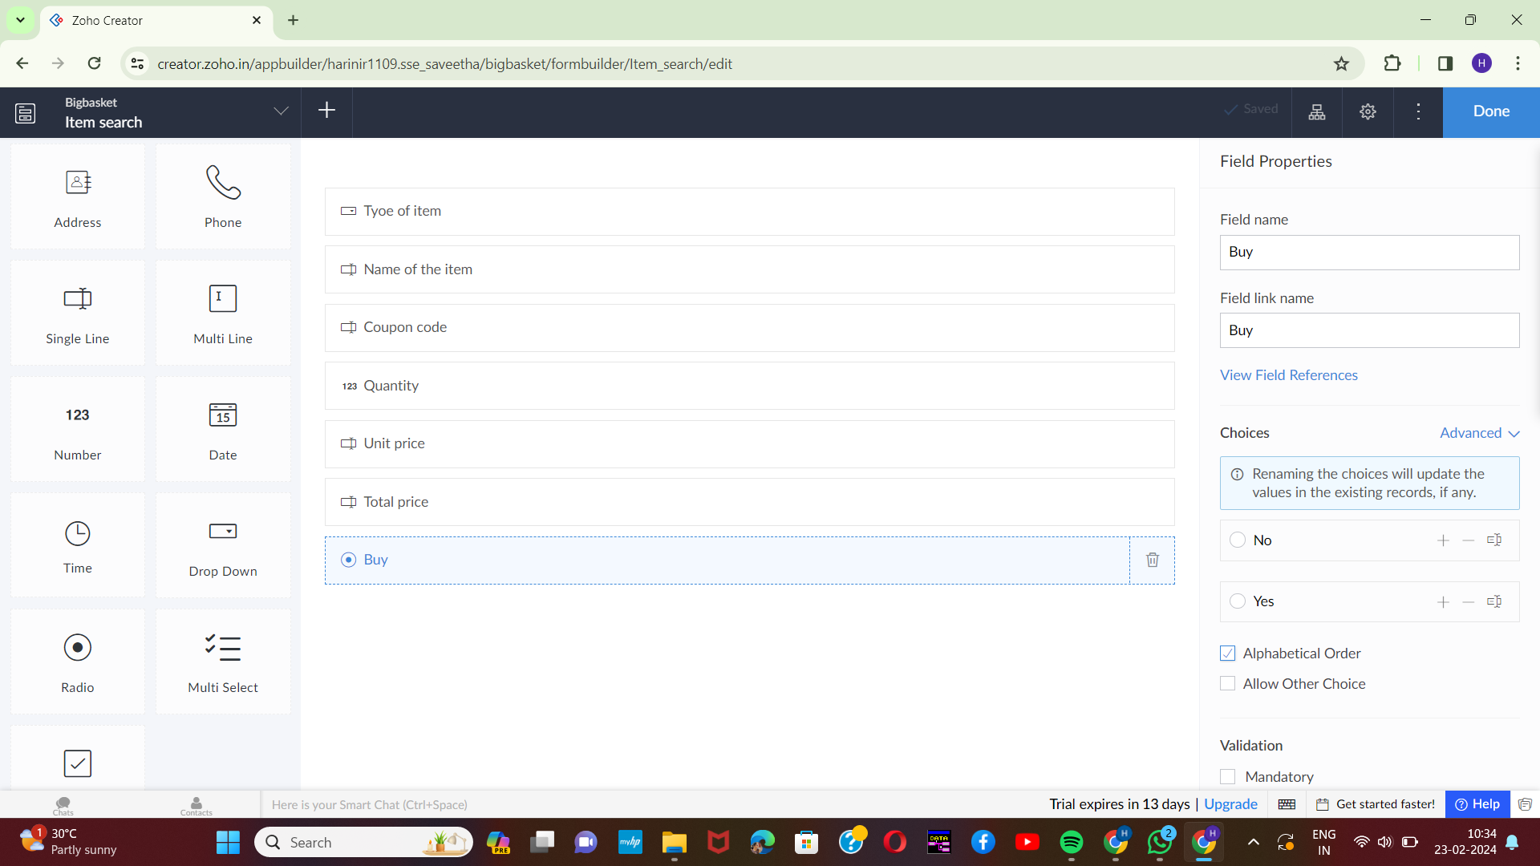

[3]STEP-4:

Execute or run the model and get the required items details from live.

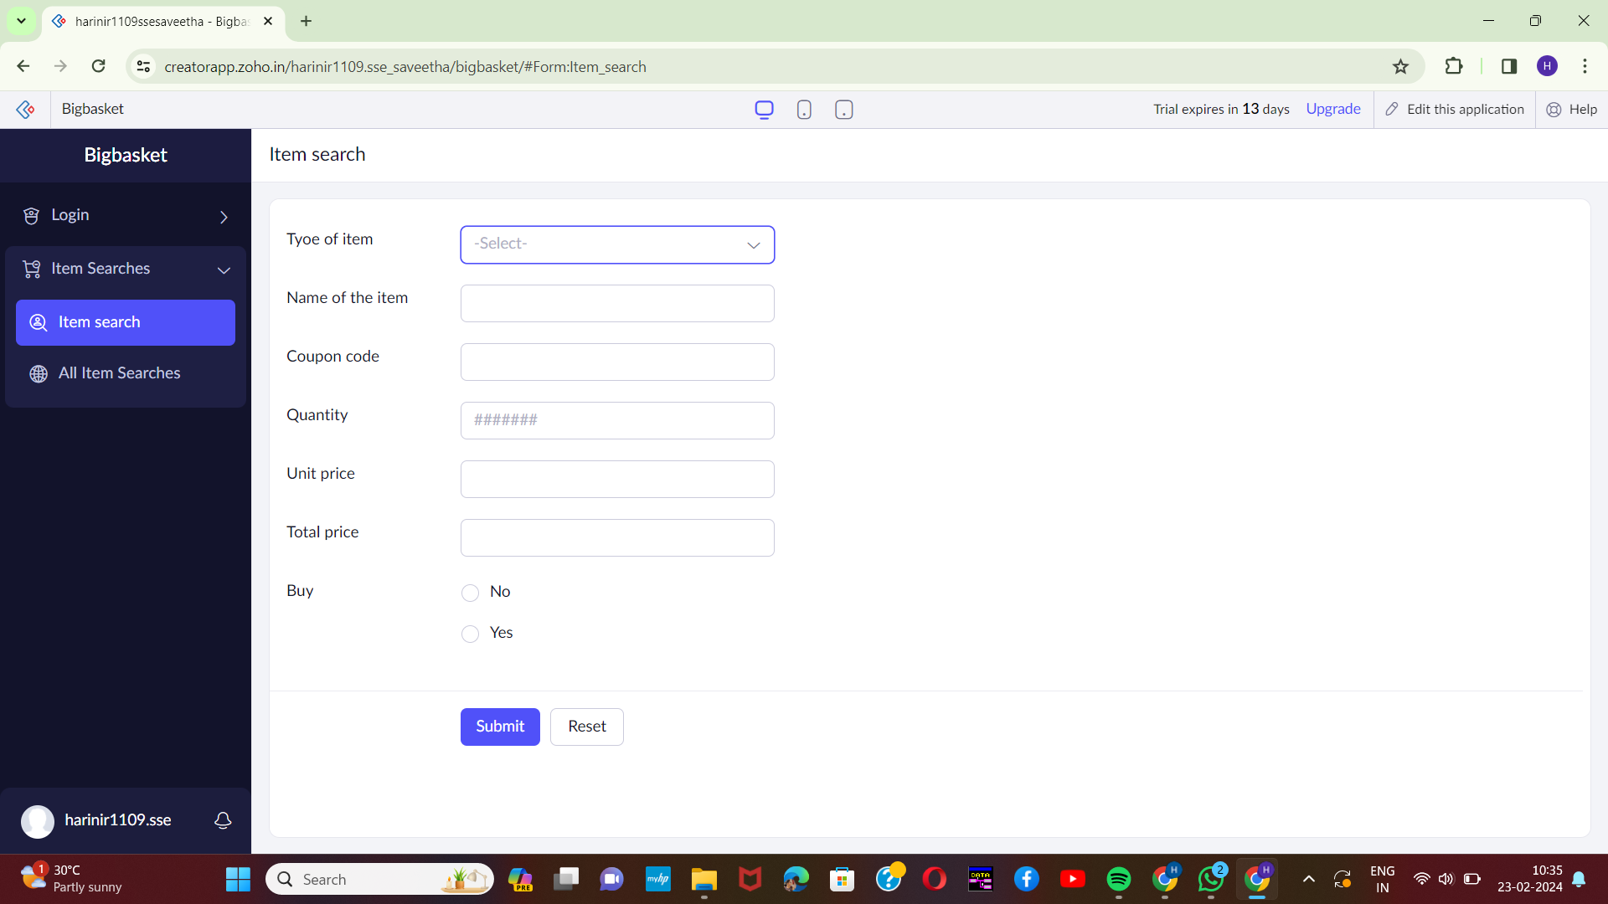

STEP-5:

Next step is to add another form which consists of customer details with the fields.

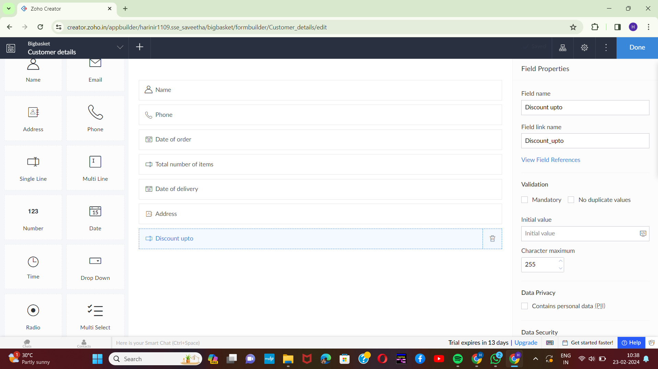

[4]STEP-6:

Execute or run the model and get the customer details from live.

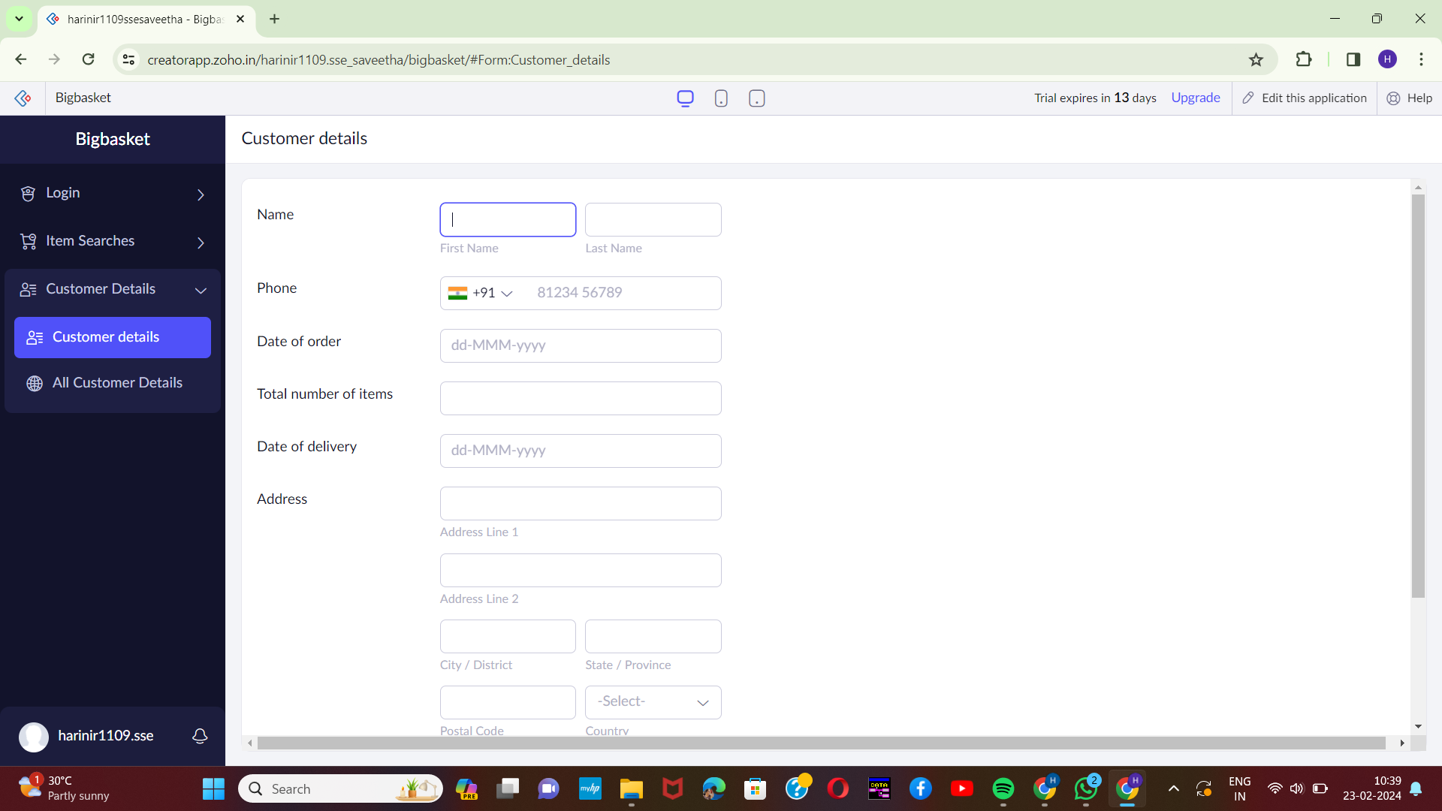

STEP-7:

Next step is to add another form which consists of logout details.

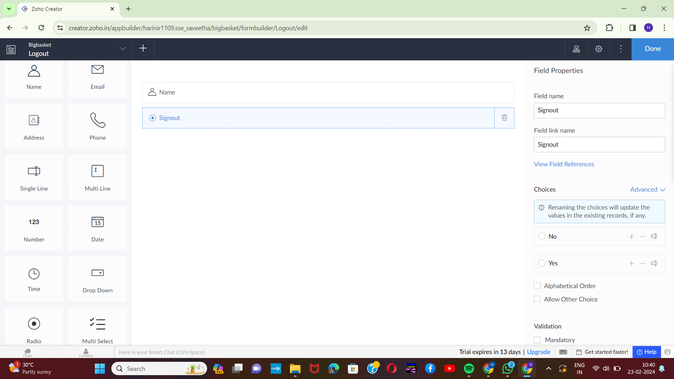

[5]STEP-8:

The last step is to run and execute the logout details form and end the program.

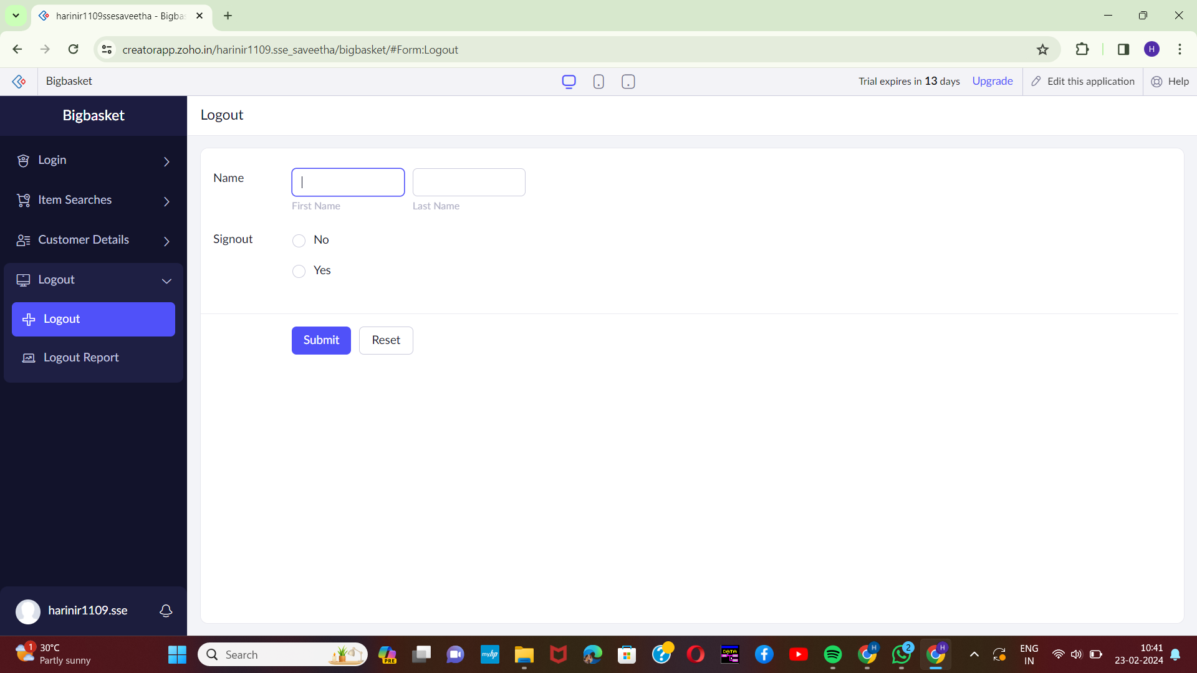

1.
2.
3.
4.
5.